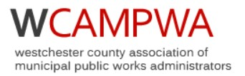

Promoting Professional Excellence

Public Works and Highway Departments
Supervisor and Foreman Training

Thursday, April 20, 2023

½ Day Session
including:
Employee Performance and Discipline
Underground Infrastructure Technology and Maintenance
Fleet Mechanics / Equipment Round Table
______________________________________

Attendance Certificate to be provided

9:00 AM to 1:30 PM

Village of Scarsdale Library
54 Olmstead Road
Scarsdale, New York 10583

Continental Breakfast and Lunch Provided

50 attendees maximum, register early

Training Registration Form

Please Print Clearly

Name:__________________________________________

Municipality:

Job Title:

Work Telephone No.:______________________________

E-mail Address:

E-mail Registration Forms to

Jim Maxwell
WCAMPWA Education Committee
Jimax153@optonline.net

Village of Scarsdale Library
54 Olmstead Road
Scarsdale, New York

Thursday, April 20, 2023
½ Day Session

Registration and Coffee 9:00 AM
Program Starts at 9:30 AM

